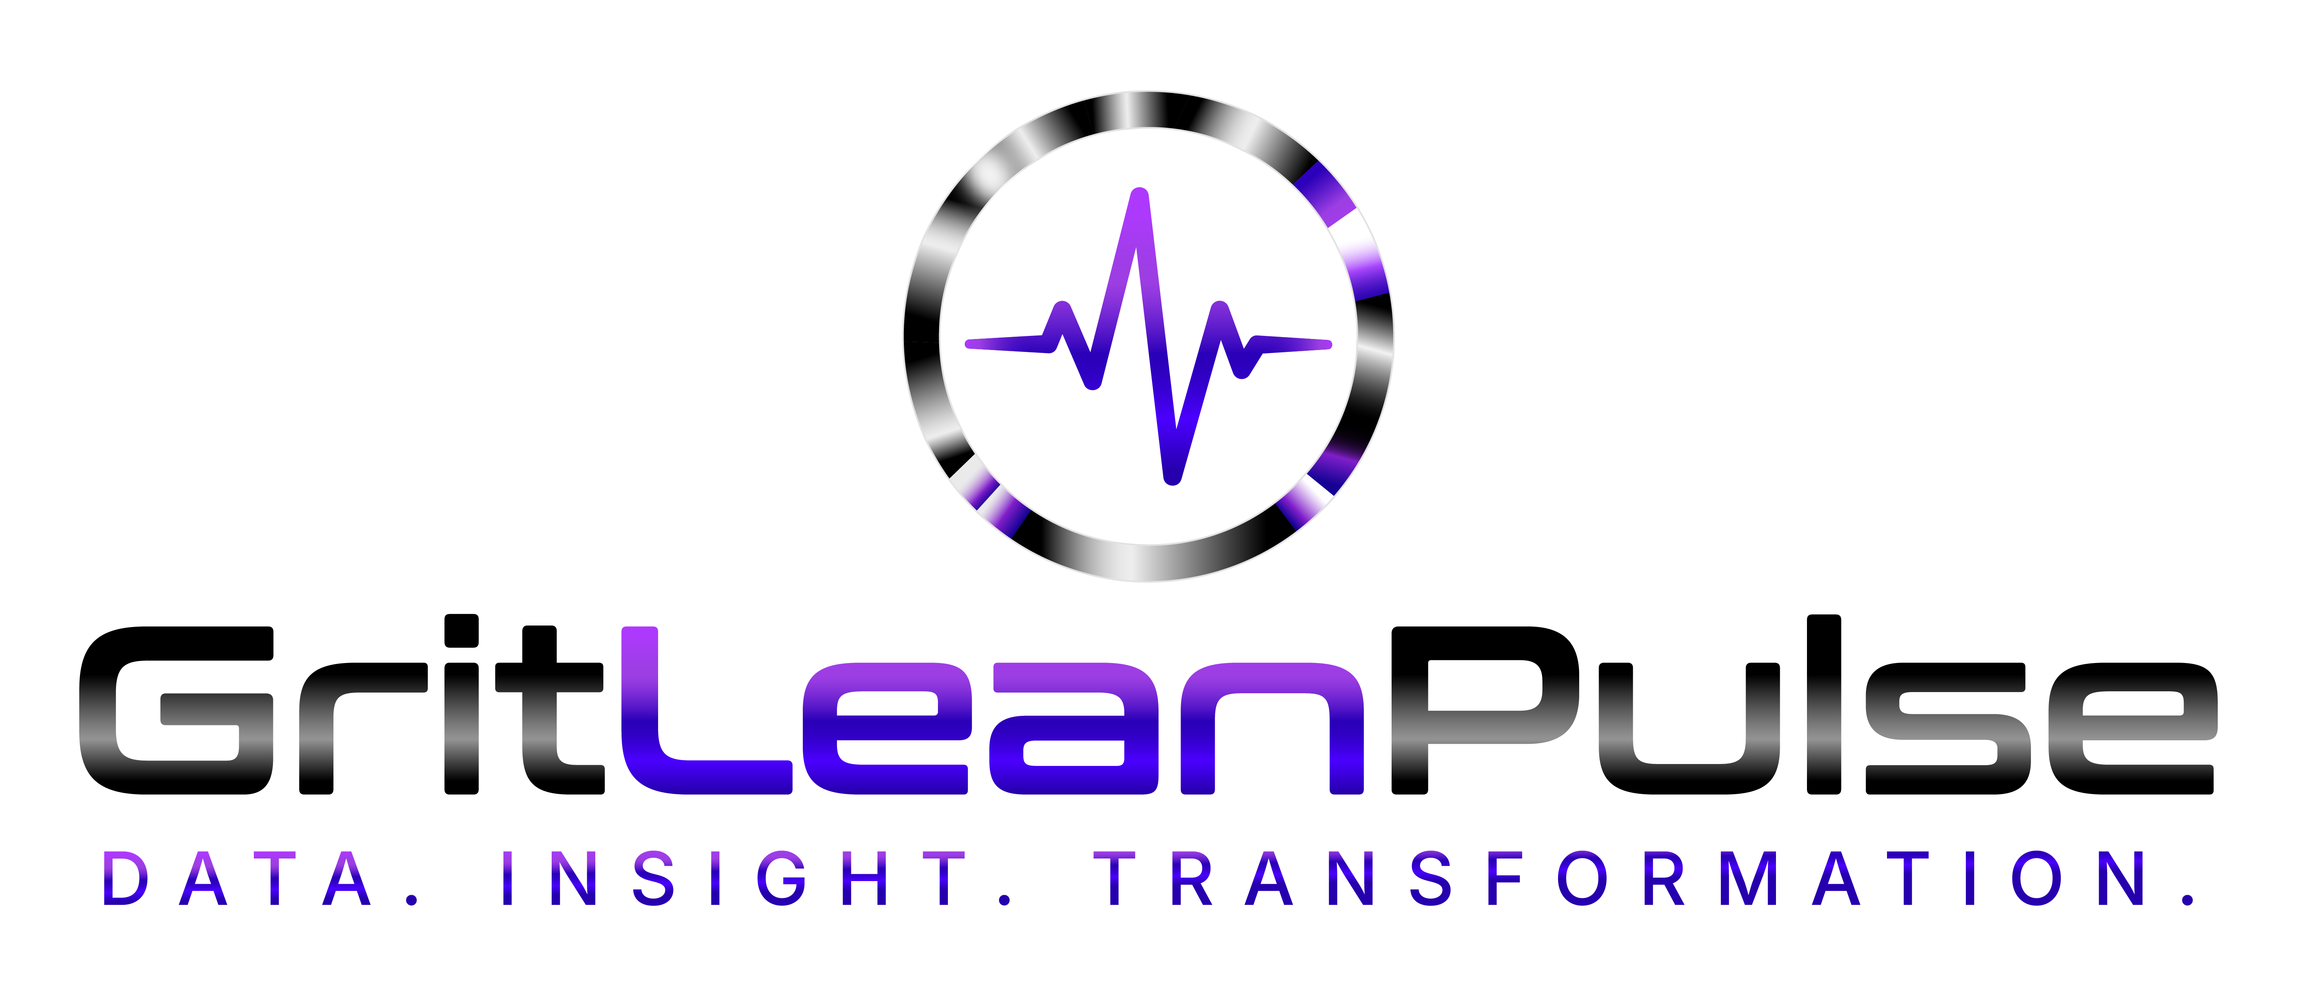

Patient Consent & Data Sharing
How patient data sharing actually works under your partnership
GritLeanPulse — SJK & Sons LLC

Sharing Is Always Patient-Initiated
A GritLeanPulse patient's account is private to them by default — enrolling with your clinic code does not automatically grant your practice access to their health data. Access only happens when a patient actively chooses to share, using their own Clinic Data Sharing controls inside the app.

What a Patient Can Choose to Share
- Provider Messaging — a direct message thread with your practice, entirely at the patient's discretion.
- Progress Reports — a snapshot they tap to send, typically before an appointment.
- Ongoing category sharing — a patient can opt into sharing specific categories (weight, macros, medications, lab results, and others) on a continuing basis, which is what powers the roster and patient-detail views in your Clinic Portal.
Whatever a patient has not opted into is never visible to your staff — the system enforces this on the server, not just in the interface, and your Clinic Portal explicitly discloses which categories a given patient has withheld rather than silently showing nothing.

What This Means for Your Practice
Your staff only ever see what a patient has consented to share. There is no way to browse a non-enrolled or non-consenting patient's data, and there is no bulk or backdoor access to information beyond what's been explicitly opted into.

For Your Own Compliance Documentation
If your practice's internal policy requires documented patient notice about data-sharing arrangements with third-party tools, you're welcome to reference this: patients control what health data (if any) is shared with your practice through GritLeanPulse, on an ongoing, revocable, opt-in basis, through settings the patient controls directly in the app.

Questions
Suzanne Evans, Founder — SJK & Sons LLC | suzanne.evans@gritleanpulse.com

