[ INSERT PARTNER LOGO ]
[ CLINIC / PHARMACY NAME ]

A note from your care team
We recommend

A comprehensive health tracking app — personalized to you, powered by AI.
📋 Track Everything  Nutrition, GLP-1 meds, labs, body measurements, fitness, sleep — all in one place. | 🤖 AI Health Coach  Personalized insights on every screen. Macro targets auto-adjust as your body changes. | 💊 GLP-1 & Meds  Injection logs, titration scheduler, medication level curves, side effect tracker.
🧬 Lab Biomarkers  120 lab values with longevity-optimized ranges and trend graphs. | ♀️♂️ Women's & Men's Health  34 women's health screens + 27 men's health screens with hormone, fertility, and more. | 🍽️ Condition Nutrition  86 condition-specific nutrition trackers — Celiac, IBD, Oncology, Renal, and more.

Your exclusive access code
[ ACCESS CODE ]
Enter this code when you create your account to unlock your partner benefits and 14-day free trial.

Get Started — Free 14-Day Trial
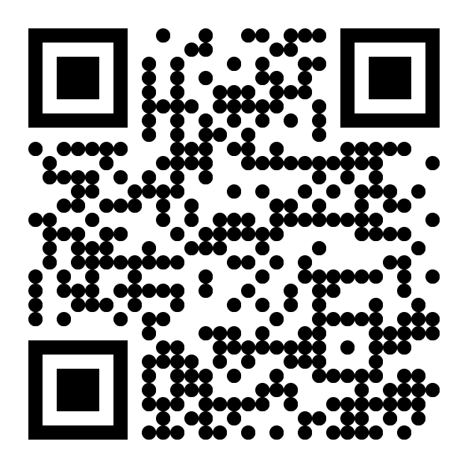
Scan to view pricing & get started

[ CLINIC NAME ] | [ PHONE ] | [ EMAIL ] | [ WEBSITE ]

